1. Objective
Enhance the existing Murabaha early-settlement process to support Ibra', allowing an institution to grant a controlled rebate on the remaining Murabaha Profit when settling financing early.
The solution shall reuse existing LMS capabilities wherever possible, particularly:
- Prepay Loan / early settlement
- Interest Payment Waiver
- Maker-Checker
- Profit Recalculation configuration
- Existing audit capabilities
- Existing Murabaha Cost Price, Profit and Selling Price
The enhancement shall apply only to Islamic Murabaha financing and shall not modify the behavior of conventional loan products.

Current LMS Behavior – Early Settlement & Profit Waiver
The LMS already provides Early Settlement (Prepay Loan) and Interest Payment Waiver capabilities. The Ibra' enhancement shall build on these existing capabilities.

1. Early Settlement – Prepay Loan
From an active financing account, the user can select:
Payments → Prepay Loan
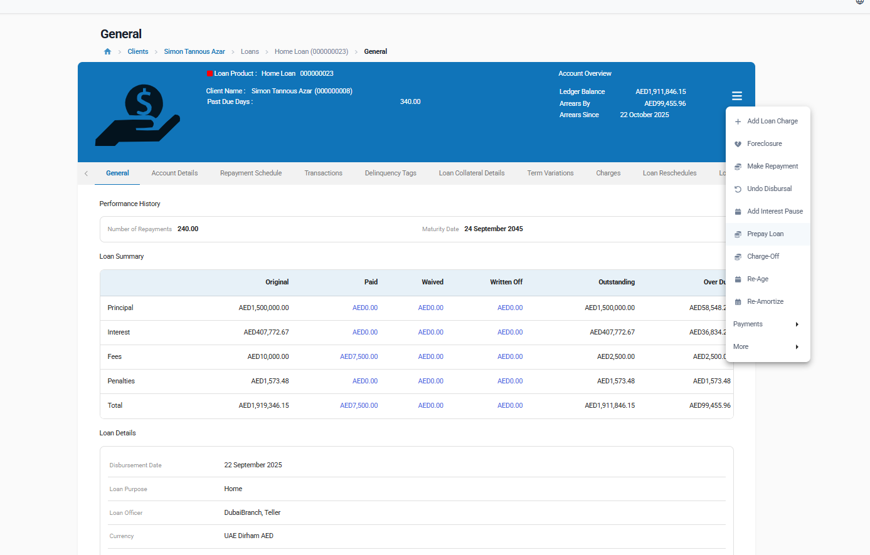
The system calculates the current settlement amount based on the outstanding:
- Financing Amount / Principal
- Profit / Interest
- Applicable Fees
- Penalties, where applicable
The calculated amount represents the amount required to fully settle the account at that point.
Current observed behavior: the Prepay Loan calculation includes the remaining outstanding Profit/Interest; it does not automatically waive the remaining Profit.
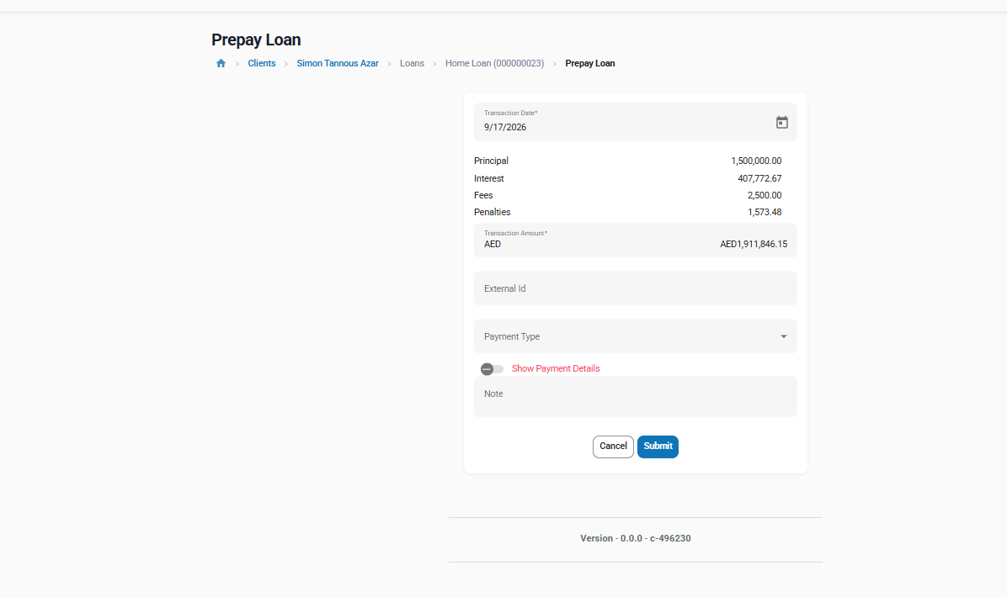

2. Interest Payment Waiver
From an active financing account, the user can select:
Payments → Interest Payment Waiver
The existing functionality allows the user to:
- Enter a waiver amount
- Apply a partial or full waiver
- Reduce the outstanding Profit/Interest by the waived amount
- Consequently reduce the amount required for early settlement
Ex
Component | Amount (AED)
Principal | 1,500,000.00
Interest | 407,772.67
Fees | 2,500.00
Penalties | 1,573.48
Transaction Amount | 1,911,846.15

Therefore, the underlying financial capability required to apply an Ibra' already partially exists through the current Interest Payment Waiver functionality.
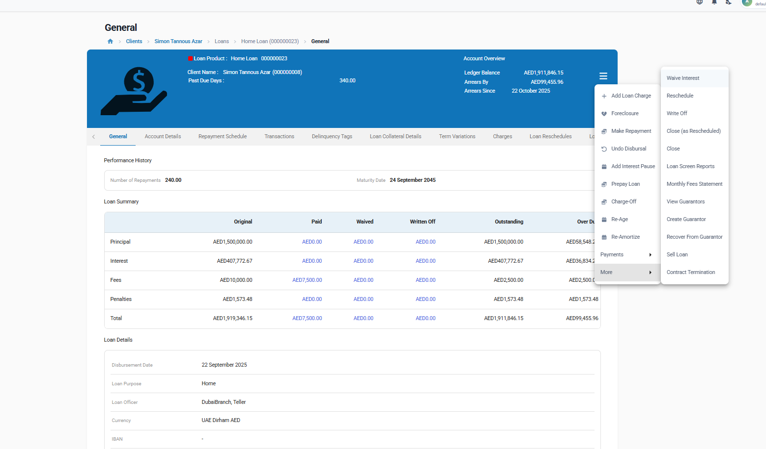

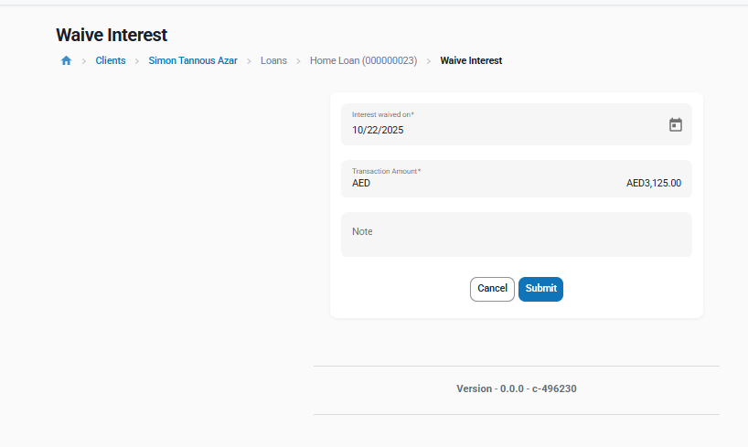

3. Profit Recalculation
At product level, the LMS provides:
Recalculate Profit = Yes / No
For Murabaha products, this can be configured as:
Recalculate Profit = No
This prevents partial prepayments from triggering the standard Profit recalculation process.
The Ibra' enhancement should therefore reuse this existing configuration rather than introduce a new partial-prepayment calculation engine.
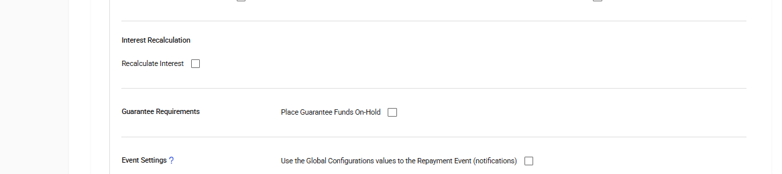

4. Current Limitations Relevant to Ibra'
The existing capabilities are generic lending capabilities and are not currently represented as a dedicated Murabaha Ibra' process.
The enhancement therefore needs to add:
- Ibra' terminology and transaction identification
- Ibra' calculation methods
- Ibra' maker-checker/approval
- Ibra' calculation and approval audit information
- Early-settlement breakdown showing Selling Price, Ibra' and Final Settlement Amount
- Islamic terminology on the relevant existing screens and outputs

Reuse Principle
The Ibra' implementation shall enhance and reuse the existing Prepay Loan, Interest Waiver, Profit Recalculation, Maker-Checker and Audit capabilities wherever possible. Existing conventional loan behavior shall remain unchanged.

BR-1 – Explicit Ibra' Transaction

Business Requirement
For a Murabaha financing account, the system shall provide an explicit Ibra' capability for granting a rebate on Profit as part of early settlement.
The existing Interest Waiver processing shall be reused as the underlying financial capability wherever possible rather than introducing a separate financial waiver engine. For Murabaha accounts, Ibra' shall be integrated into the Early Settlement flow and shall not be exposed as a separate payment action.
For Murabaha accounts , the customer-facing/business terminology shall be:
Ibra' / Profit Rebate
instead of:
Interest Payment Waiver

Business Rules
- Ibra' shall only be available for an Islamic product where Financing Type = Murabaha.
- Ibra' shall reduce the remaining Profit component.
- Ibra' shall not reduce the outstanding Cost / Financing Amount.
- Applying Ibra' shall reduce the resulting early-settlement amount.
- The Ibra' transaction shall be identifiable separately in the Murabaha account transaction history.
- Conventional loans shall continue to use the existing Interest Payment Waiver functionality and terminology.

Existing Capability to Reuse
Payments → Interest Waiver
The underlying waiver processing shall be reused for the Ibra' financial treatment. For Murabaha, the user shall access Ibra' through the Early Settlement flow; a separate Ibra' / Profit Rebate payment action shall not be displayed.
Conventional loans shall retain the existing Interest Payment Waiver action and flow.

BR-2 – Configurable Ibra' Calculation

Business Requirement
The institution shall be able to configure how the eligible Ibra' amount is determined for a Murabaha product.
Add an Ibra' Configuration section to the Murabaha product.

Configuration

Allow Ibra'
- Yes / No
- Default: No

Ibra' Calculation Method
- Unearned Profit
- Fixed Percentage
- Manual Amount
- Unearned Profit less Applicable Administration

Calculation Rules

Unearned Profit
The eligible remaining/unearned Profit shall be proposed as the Ibra' amount.
Unearned Profit less Applicable Administration / Early Settlement Charges

- When this method is selected, the product configuration shall display a mandatory Administration / Early Settlement Charge(s) to Deduct field.
- The field shall reuse the existing product Charge selection capability and shall be presented as a multi-select dropdown, allowing one or more applicable charges to be selected.
- The dropdown shall list only eligible charges already configured / attached to the Murabaha loan product and designated by the institution as applicable for deduction from Ibra' / Early Settlement. Charges that are not eligible for Ibra' deduction shall not be selectable.
- The Ibra' configuration shall reference the selected charge(s); it shall not require the Product Administrator to manually re-enter the charge amount.
- At Early Settlement, the system shall determine the applicable amount of each selected charge using the existing charge configuration and shall calculate the total applicable selected charges.
  - Calculated Ibra' = Eligible Unearned Profit - Total Applicable Selected Administration / Early Settlement Charges.
  - The Calculated Ibra' amount shall not be less than zero.
  - The selected charge(s) used to reduce Ibra' are distinct in treatment from outstanding Fees / Charges and Penalties that may be payable on the financing account and added to the Final Settlement Amount
  - The same charge amount shall not be counted twice for the same purpose, i.e. it shall not both reduce Ibra' and be added separately to the Final Settlement Amount as the same settlement charge.

Example:
Eligible Unearned Profit = 1,000;
applicable selected Charge A = 50;
applicable selected Charge B = 25; T
otal Applicable Charges = 75;
Calculated Ibra' = 925.

Fixed Percentage
When the user selects:
Allow Ibra' = Yes
Ibra' Calculation Method = Fixed Percentage
an additional field should appear: Ibra' Percentage (%) *
For example:
Allow Ibra' = Yes
Ibra' Calculation Method: Fixed Percentage
Ibra' Percentage (%): 80
I would add this under Configuration:

Ibra' Percentage (%)
- Displayed and mandatory only when Ibra' Calculation Method = Fixed Percentage.
- Defines the percentage of Eligible Unearned Profit to be granted as Ibra'.
- Value must be greater than 0 and less than or equal to 100.
- Hidden/not applicable for Unearned Profit and Manual Amount.
Then the existing formula remains:
Ibra' = Eligible Unearned Profit × Ibra' Percentage

Manual Amount
The authorized user enters the proposed Ibra' amount manually.

Ibra' Validation
The system shall ensure that the Ibra' amount does not exceed the eligible remaining Profit available for rebate.
For example:
Eligible remaining Profit: AED 5,000
Ibra' requested: AED 3,000 → Allowed
Ibra' requested: AED 6,000 → Rejected and show error message : ‘Ibra' amount cannot exceed the eligible remaining Profit. Please enter a valid amount. ‘

Allow Ibra' Override

The Murabaha product configuration shall provide an Allow Ibra' Override option.
- The default value shall be No.
- Allow Ibra' Override shall be displayed only when Allow Ibra' = Yes and the selected Ibra' Calculation Method is a system-calculated method: Unearned Profit or Fixed Percentage.
- When Ibra' Calculation Method = Manual Amount, Allow Ibra' Override shall be hidden / not applicable because the Ibra' amount is entered manually during Early Settlement.
- When Allow Ibra' Override = No,
  - the system-calculated Ibra' amount shall be read-only during Early Settlement.
- When Allow Ibra' Override = Yes,
  - An authorized user may modify the system-calculated Ibra' amount during Early Settlement.
  - The overridden amount shall not exceed the Eligible Ibra' / remaining eligible Profit.
- When the system-calculated Ibra' amount is modified, Override Reason shall be mandatory.
- The system shall retain the Calculated Ibra' Amount, Proposed / Overridden Ibra' Amount, Override indicator and Override Reason for Maker-Checker review and audit.
- For system-calculated methods, the Early Settlement screen shall display the Calculated Ibra' Amount. The amount shall be editable only when Allow Ibra' Override = Yes.
- For Manual Amount, the user shall enter the Ibra' amount directly, subject to the Eligible Ibra' limit; this shall not be treated as an override.

Example:
Eligible remaining Profit = 1,000 and Fixed Percentage = 80%. The system-calculated Ibra' is 800. If override is disabled, 800 is read-only. If override is enabled, an authorized user may propose 950, subject to the eligible Ibra' limit and mandatory Override Reason.

BR-3 – Ibra' Maker-Checker

Business Requirement
Ibra' requests shall support approval through the existing LMS Maker-Checker framework.
The solution shall not introduce a separate approval framework.

Flow
Maker calculates/enters Ibra'
→ Reviews early-settlement quotation
→ Submits
→ Checker reviews
→ Approves or Rejects
→ Ibra' is applied upon approval

Business Rules
- The Ibra' shall not affect the financing balance before approval.
- The Checker shall see the calculation method, calculated amount, any manual override, reason and resulting settlement amount.
- Rejection shall leave the account unchanged.
- Existing Maker-Checker rules regarding self-approval and permissions shall continue to apply.
Where Maker-Checker is not enabled/applicable, the Ibra' may be applied directly according to existing LMS authorization rules.

Automatic Approval for Customer Self-Service
Add the following settings to the Ibra' Configuration of the Murabaha product:
Field | Type | Default | Rule
Auto-approve Ibra' for Customer Self-Service | Yes / No | No | Displayed only when Allow Ibra' = Yes.
Maximum Auto-approved Ibra' Amount | Amount (optional) | Empty (no limit) | Displayed only when Auto-approve = Yes. Above this amount the request goes to a checker.
When Auto-approve = Yes, an early settlement shall be applied without checker approval only if all of the following are true:
● the request is initiated by the customer through the mobile app / customer API (identified by the app's integration user / channel);
● the Ibra' is system-calculated (Unearned Profit, Fixed Percentage, or Unearned Profit less Applicable Charges);
● the calculated Ibra' is not overridden;
● the Ibra' amount does not exceed the Maximum Auto-approved Ibra' Amount, when set.
In all other cases the existing maker-checker flow applies. Manual Amount and overridden Ibra' are not available through self-service. Auto-approved Ibra' is recorded in the audit (BR-4) with Approved By = "System – customer self-service".

BR-4 – Ibra' Details & Audit

Business Requirement
The system shall retain sufficient information to reconstruct how each Ibra' was calculated, requested and approved.
For every Ibra' request, record at minimum:
Information | Requirement
Financing Account | Account receiving the Ibra'
Calculation Method | Method configured/used
Remaining Profit | Profit before Ibra'
Eligible Ibra' | System-calculated eligible amount
Proposed Ibra' | Amount requested
Approved Ibra' | Final approved amount
Override | Whether calculated amount was overridden
Override Reason | Mandatory where applicable
Ibra' Reason | Business reason
Requested By | Maker
Request Date/Time | Timestamp
Approved/Rejected By | Checker
Approval Date/Time | Timestamp
Final Settlement Amount | Amount after Ibra'
Transaction Reference | Resulting financial transaction
Existing audit capabilities shall be reused wherever possible.

BR-5 – Partial Prepayment & Contractual Profit

Current Capability
Already supported through product configuration.
Murabaha products shall use:
Recalculate Profit = No
With this configuration, partial prepayments shall not trigger the standard Profit recalculation process.

Business Requirement
For Murabaha products configured with Recalculate Profit = No, partial prepayment shall not automatically recalculate the remaining Profit.
Any explicit reduction of Profit associated with early settlement shall be processed through the Ibra' capability.

⇒ Enhancement Control
As part of the Murabaha configuration, the system should default/enforce Recalculate Profit = No to prevent incompatible configuration.
No new partial-prepayment calculation engine is required.

Ibra' on Partial Early Settlement
Product setting Allow Ibra' on Partial Settlement = Yes / No (default No), displayed only when Allow Ibra' = Yes. When No, partial prepayment continues as today (no Profit reduction).
Where: the existing Early Settlement (Prepay) action gains a Settlement Type: Full / Partial choice (back-office screen and customer API). Ibra' on partial settlement is not applied from the Repayment screen, so that automatic collections and payment-gateway overpayments never trigger a rebate that nobody requested.
How:
● Due amounts are paid first. Before any future installment is settled, the settlement pays all overdue and due amounts, i.e. installments with a due date on or before the settlement date, oldest first, together with any late charges. No Ibra' is granted on these amounts, because their Profit is already earned.
● The user then selects the number of future installments to settle early. These are settled from the last installment backwards (tenor is shortened; the amounts of the other installments do not change).
● Ibra' is calculated with the product's configured method, applied only to the unearned Profit of the selected future installments.
● Amount to pay = overdue and due amounts (including late charges) + Financing Amount of the selected future installments + their Profit + applicable charges − Ibra'.
● The screen and the API show the overdue and due amount as a separate line of the breakdown, so the customer sees why the amount is higher than the selected installments.
● After posting, the account has no overdue amount; the settled installments are closed and the remaining installments keep their contractual Profit (no recalculation, Recalculate Profit = No).
● Same validation, override, maker-checker / auto-approval, audit and terminology rules as full early settlement.
Implementation note (custom development): a dedicated allocation shall be developed for the Early Settlement action when Settlement Type = Partial: (1) pay overdue and due amounts in the strategy's usual component order; (2) close the selected installments starting from the last one; (3) apply Ibra' to the unearned Profit of those installments. .
Example 1 – no arrears: Cost Price 10,000, Profit 1,500, 12 monthly installments, 3 already paid, installment 4 not yet due. Partial settlement of 3 installments → installments 12, 11, 10. Financing Amount 937.539 + 917.185 + 897.279 = 2,752.003; Profit 20.798 + 41.148 + 61.054 = 123.000 (all unearned). Method Unearned Profit (100%) → Ibra' = 123.000. Customer pays 2,752.003. Installments 4–9 unchanged; the financing now matures at installment 9.
Example 2 – with arrears: same financing, but installment 4 (April, 958.333) is due and unpaid on the settlement date. The settlement first pays installment 4 in full (958.333 plus any late charges, no Ibra'), then installments 12, 11, 10 as in Example 1 (Ibra' 123.000). Customer pays 958.333 + 2,752.003 = 3,710.336 (plus any late charges). Installments 5–9 unchanged; the account shows no overdue amount; the financing matures at installment 9.
Paying down the outstanding balance so that all remaining installments become smaller (instead of shortening the tenor) is not included; it would require regenerating the remaining schedule.
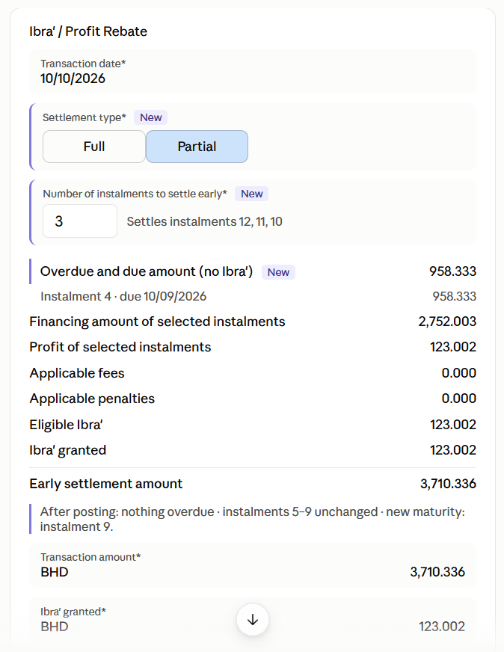
Early settlement screen - Adding Partial settlement options

BR-6 – Murabaha Early Settlement Breakdown

Business Requirement
Before confirming early settlement, the system shall clearly display the contractual amounts and the effect of Ibra'.
The early-settlement view shall display at minimum:
Field | Description
Remaining Financing Amount | Outstanding Cost/Financing component
Remaining Profit | Outstanding contractual Profit
Remaining Selling Price | Remaining Financing Amount + Remaining Profit
Applicable Fees/Charges | Any applicable settlement charges
Eligible Ibra' | Maximum/calculated rebate
Ibra' Granted | Actual rebate applied
Final Settlement Amount | Amount customer must pay

Calculation
Final Settlement Amount = Remaining Selling Price + Applicable Fees/Charges − Ibra'
Example:
Component | Amount
Remaining Financing Amount | 4,500
Remaining Profit | 500
Remaining Selling Price | 5,000
Ibra' | (400)
Final Settlement Amount | 4,600
The user shall see this breakdown before submitting/approving the settlement.

Exposure through the API (Customer App)
The early-settlement quotation API (the existing Prepay Loan / early-settlement transaction template) shall return, for Murabaha accounts, the same breakdown as the screen:
● Remaining Financing Amount, Remaining Profit, Remaining Selling Price
● Applicable Fees / Charges
● Ibra' Calculation Method, Eligible Ibra', Ibra' Granted
● Final Settlement Amount and the quotation date (valid for that settlement date)
● Settlement Type (Full / Partial) and, for Partial, the installments covered
The settlement confirmation API shall accept the quoted amounts so that the customer pays exactly what was displayed. Terminology follows BR-7.

BR-7 – Islamic Early Settlement Terminology

Business Requirement
Customer-facing Murabaha screens, APIs and settlement outputs shall use approved Islamic financing terminology rather than conventional lending terminology.
Existing conventional terminology shall remain unchanged for conventional products.

Terminology
For Murabaha:
Existing/Technical Term | Customer-Facing Murabaha Term
Principal | Financing Amount / Cost
Interest | Profit
Interest Payment Waiver | Ibra' / Profit Rebate
Outstanding Principal + Interest | Remaining Selling Price
Interest Saved/Waived | Ibra' Granted
Prepayment Amount | Early Settlement Amount

Existing Screens/Capabilities to Enhance
The enhancement should apply to the existing capabilities rather than creating duplicate screens:
Loan Account → Payments → Prepay Loan
Enhance to display the Murabaha settlement breakdown and Ibra'.
For Murabaha, use Early Settlement as the single user entry point. Enhance the existing Prepay Loan / Early Settlement capability to display the Murabaha settlement breakdown, calculate/apply Ibra' according to the configured method, and show the resulting Final Settlement Amount.
Loan Account → Payments → Interest Waiver (underlying capability only for Murabaha)
For Murabaha, reuse the existing Interest Payment Waiver processing as the underlying Ibra' capability, but do not display a separate Ibra' / Profit Rebate payment action. Conventional loans shall continue to expose the existing Interest Payment Waiver action unchanged.

Loan Account → Transactions
Display the resulting transaction as Ibra' for Murabaha accounts.
Early Settlement / Prepayment Preview
Display Financing Amount, Profit, Selling Price, Ibra' and Final Settlement Amount separately.
Any customer-facing settlement document/API shall use the same terminology.

Overall Acceptance Criteria
- Ibra' is available only for eligible Murabaha products.
- Existing Interest Waiver processing is reused where technically appropriate.
- Ibra' supports the configured calculation method.
- When Fixed Percentage is selected, Ibra' Percentage (%) is displayed, mandatory, and accepts values greater than 0 and less than or equal to 100.
- For Murabaha, Ibra' is integrated into the Early Settlement flow and no separate Ibra' / Profit Rebate payment action is displayed.
- Ibra' cannot exceed eligible remaining Profit.
- Ibra' cannot reduce the Cost/Financing Amount.
- Maker-Checker is supported using the existing framework.
- No financial impact occurs before required approval.
- Approved Ibra' reduces remaining Profit and the early-settlement amount.
- Partial prepayment with Recalculate Profit = No does not trigger standard Profit recalculation.
- Early-settlement preview clearly shows Remaining Selling Price → Ibra' → Final Settlement Amount.
- Murabaha screens and outputs use Islamic terminology.
- Conventional products remain completely unchanged.
- Ibra' calculation, overrides, approvals and resulting transaction are fully auditable.
- The early-settlement API returns the full Murabaha breakdown including Eligible Ibra' and Ibra' Granted.
- With Auto-approve = Yes, customer-initiated settlement with system-calculated, non-overridden Ibra' within the limit is applied without checker; all other cases follow maker-checker.
- With Allow Ibra' on Partial Settlement = Yes, a partial settlement of N installments closes the last N installments, applies Ibra' only to their unearned Profit and leaves the other installments unchanged.
- When overdue or due amounts exist on the settlement date, a partial settlement first pays them in full (no Ibra') before closing the last N installments; after posting, the account has no overdue amount. With Block Partial Settlement while in Arrears = Yes, the Partial option is not available while the account is overdue.

BEDE Functional Requirements Coverage
Mapping of this BRD to the BEDE LMS Scope & Requirements.
BEDE Req | BEDE requirement (short) | Coverage | Where | Remark
FR-10 | Ibra' rules configurable per product for early and partial settlement | Covered | BR-2, BR-5 | Full and partial early settlement; partial enabled per product (Allow Ibra' on Partial Settlement).
FR-18 | Early settlement options (without profit, with profit, fixed fee, % of settled amount) + quote in-app | Covered (one dependency) | BR-2, BR-3, BR-6 | Without profit = Unearned Profit; with profit = Allow Ibra' = No; fixed fee / % of settled amount = Unearned Profit less Applicable Charges, using the Early Settlement charge from roadmap items #12 / #13. In-app quote through the API.
FR-19 | Partial payment with the same charging options + schedule recalculation | Covered | BR-5 | Partial early settlement uses the same Ibra' methods and charges; remaining installments are not recalculated (Profit protected).
FR-25 | Settlement quotes on demand from app and back-office | Covered | BR-6 | Same breakdown on screen and API.
FR-24 | Fee waiver / refund / overpayment with maker-checker | Partly | BR-1, BR-3 | Profit waiver only through Ibra'. Fee waiver, refund and overpayment use existing behaviour.
FR-32 | Maker-checker on financial adjustments | Covered | BR-3 | With controlled auto-approval for self-service.
FR-33 | Immutable, exportable audit trail | Covered | BR-4 | Incl. auto-approved Ibra'.
INT-01 | Mobile app journeys (§4.3) | Covered for early settlement | BR-6, BR-3 | Quote and confirmation through the API.
FR-09 / FR-11 / FR-38 | Late charges to charity, GL postings, settlement reports | Not in scope | — | Covered by the late-payment, Murabaha accounting and reporting FRDs.

